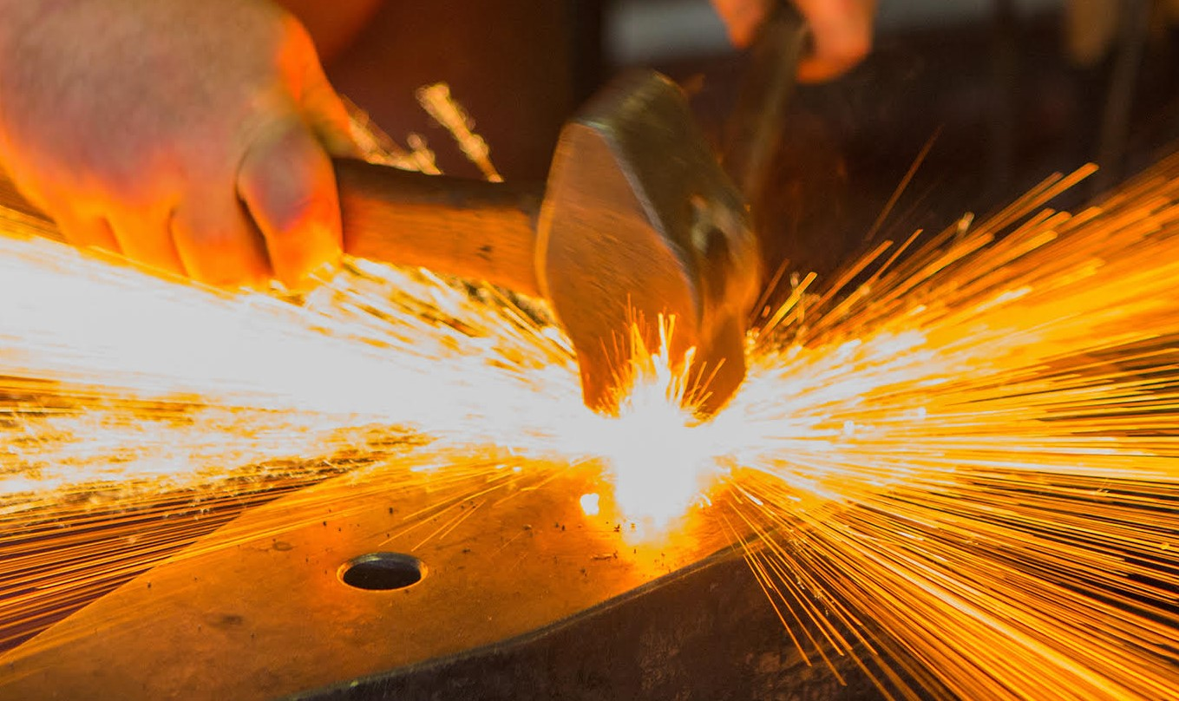
BLACKSMITHING OPEN HOUSE for veterans
Come Smite Hot Iron
Florida Artist Blacksmith Association (FABA) will host Blacksmithing for Veterans on Saturday, September 25th , 0900- 1800 at Iron Osprey Forge in St. Augustine, FL. (Iron Osprey Forge 102 Marshall Circle off Dobbs Rd).
There will be an open hospitality tent for folks to meet & greet or just hang out and watch demonstrations of blacksmithing . Refreshments provided free of charge. This is open to all comers but with an emphasis on those who served our country.
Veterans can make a small project for free or schedule a formal lesson.
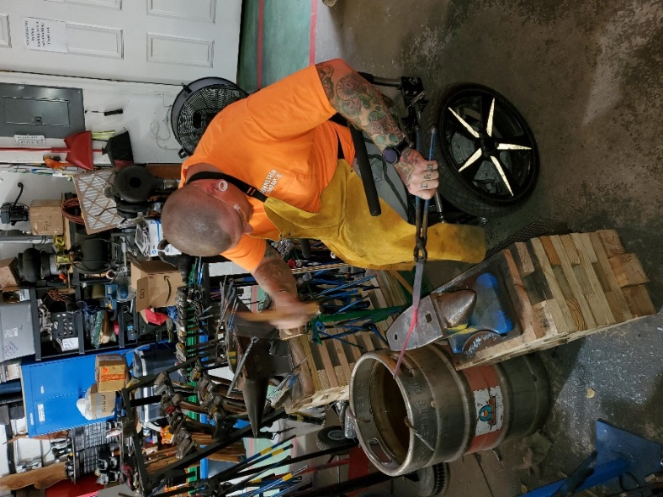
For the Veterans’ classes there will be scheduled times available throughout the day with a nominal fee of $5 for 2 hours of forge time and the veteran will leave with a useful project they made themselves. Each veteran who signs up for the forge can have a companion with them in the forge to assist if needed. No prior experience is needed. We can handle those with prosthetics or wheelchairs and will do our best to let you hit metal with your brothers.

Go to www.iron-osprey-designs.com for more information.

Florida Artist Blacksmith Association (FABA) is a non-profit educational organization dedicated to preserving and teaching the craft of blacksmithing. FABA has members across Florida as well as across the county and offers monthly meetings and events as well as an annual statewide conference.
Working with the North Northeast FABA region and Iron Osprey Forge, FABA is presenting an Open House/ Open Forge event for veterans, but also open to the public in St. Augustine on September 25th.
There will be an open hospitality tent with ongoing demonstrations of blacksmithing skills, an opportunity for folks to hit hot iron and create a useful item to take home.
For veterans interested in learning more, a limited number of spots are open for veterans to receive a 2 hour intro class to learn some basics of the blacksmithing craft.
There will be free refreshments and drinks available all day, as well as lunch for attendees.
The event will begin at 9 a.m. at Iron Osprey Forge (102 Marshall Circle, St. Augustine – just off of Dobbs Road, south of SR 207) and will go all day until 6 p.m.
Iron Osprey Forge offers classes as well as ornamental and functional iron work and has made accommodations for persons with physical limitations including wheelchair accessible workstations and anvils.
Interested folks will benefit from reviewing the ‘safety information’ section of the Iron Osprey website, especially regarding clothing.
If you are interested in registering for one of the limited blacksmith classes or want more information, contact Doug Hayes at Iron Osprey Forge djhayes@iron-osprey-designs.com or 904-460-2762.

